**Bloomin’ Brands: Fleming’s Steakhouse**

MKT 617 Big Data Project

By: Benjamin Ayres, Callie Kesilewski, Sathvika Kokku, Arya Karmacharya, and Vasundhara Kamal

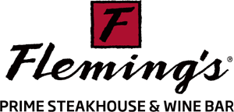

***Table of Contents***

**Executive Summary……………………………………….…………………………………........ 1**

**Industry Background…………………………………….…………………………….…………. 2**

**Company Background…………………………………………………………………………..... 3**

**Research Problem.…………………..………………………………………..…………………... 4**

**Research Plan, Sampling, and Methodology………………………………………………...... 4**

**Data Analysis and Findings………………………………………………..…….……………… 8-25**

**Recommendations……………………………………………………………………………….. 26-28**

**Conclusion……………………..……………………………………………………………………. 29**

**Executive Summary:**

This project aims to enhance the dining experience at Fleming’s Prime Steakhouse & Wine Bar by gathering data from our target audience, which includes current and potential customers of fine-dining restaurants.

To do this effectively, Fleming’s needs to understand what their customers care about most, such as the variety of steak cuts, wine selection, atmosphere, and quality of service. Patterns will be identified among customers who value similar aspects of a fine-dining steakhouse. Through identifying patterns, the target audience can be divided into multiple segments. It also examines how guests feel about Fleming’s, highlighting what the restaurant is doing well and determining areas of improvement. To address these challenges, data was collected through an online survey and gathered reviews from websites like Open Table and Yelp to conduct three critical analyses.

1. **Segmentation Analysis:** The segmentation analysis identifies distinct customer groups based on customer preferences like service quality, price, wine and cocktail list, steak variety, and dining atmosphere, along with demographic data such as age, income, and education. By analyzing survey responses through cluster analysis, the target audience’s specific preferences can be understood and identified through three distinct customer segments.
2. **Sentiment Analysis:** Using sentiment analysis, the reviews from Open Table and Yelp will be evaluated to understand guest sentiments toward Fleming's Steakhouse, identifying key themes, keywords, and trends. Through comparing Fleming's reviews with its competitors’, insights can be gained about customer experiences and preferences in the fine dining steakhouse category.
3. **Perceptual Maps:** Perceptual maps were used to see how Fleming's Steakhouse compares to other high-end steakhouses in Tampa regarding steak variety, atmosphere, service quality, wine and cocktail list, and price. This visual comparison helps us spot where Fleming's stands out and where it might need improvement. These insights suggest Fleming’s should enhance its service quality and menu variety while maintaining its strong reputation for ambiance and value.

Fleming’s stands out for its affordability and ambiance but falls behind competitors like Ruth’s Chris in service quality and Ocean Prime in menu variety. Customers value the atmosphere and trust the brand but have raised concerns about slow service and noise levels. To address these issues, Fleming’s should improve service speed and create a quieter, more comfortable environment for specific customers. Flemings can focus on creating tailored strategies for each group identified through segmentation analysis to ensure customers' needs are satisfied. Additionally, enhancing steak offerings and diversifying the menu will help Fleming’s better compete and meet customer expectations.

**Industry Background:**

According to IBISWorld 2024, the premium steak restaurant industry consists of high-end dining establishments that average $50.00 or more per customer. The main task for these restaurants is to provide their customers with a memorable, luxury experience. Because this industry is high-end and provides the highest quality of food, households who dine in this category are earning more than $100,000 a year. Another prominent segment within the industry is consumers working for corporate America. Although this is currently the case when talking about the industry, premium steakhouses are also attracting lower socioeconomic consumers, as establishments are popular locations for celebrations and special occasions, such as birthdays and anniversaries.

Looking at the external environment, IBISWorld (2024) conducted a SWOT analysis of the industry, which includes:

* Strengths: Low Imports, Low product and service requirements
* Weaknesses: Low/increasing barrier to entry and very high volatility
* Opportunities: Future high revenue growth and consumer spending
* Threats: Potential future low revenue growth and low performance drivers

Four essential product and service lines will take up the industry, according to IBISWorld 2024. Classic steak restaurants account for 59.7%, followed by steak and seafood restaurants at 34.8%, premium Brazilian steak restaurants at 1.5%, and other premium steak restaurants at 4.0% (IBISWorld, 2024). Based on the statistics above, classic steak and steak/seafood restaurants account for most of the revenue within this industry. Specifically, these two types of restaurants focus on providing consumers with premium steak and seafood options. These restaurants provide various cuts of red meat, premium seafood, and an assortment of wine options to complement meals.

Geographically, the Southeast, West, and Mid-Atlantic regions contain most of the consumers in the U.S. Among these regions, five prominent companies are the major players in the industry: Darden Restaurants Inc., Ruth’s Hospitality Group Inc., Fleming’s Prime Steakhouse and Wine Bar, and Fogo De Chao, Inc. Currently, both Darden Restaurants Inc. and Ruth’s Hospitality Inc. are the two most significant in the industry. According to IBISWorld (2024), they account for 10.6% of the industry.

Since COVID, the premium steak restaurant industry has been increasing in revenue. This upward trend is due to many factors, including business clients renting space for corporate events, high-income households wanting a luxurious night out, and demand from middle and lower-income households experiencing changes in income. The industry revenue is expected to increase by 1.8% over five years, reaching $8.7 billion by 2029 (IBISWorld, 2024).

**Company Background:**

Fleming’s Prime Steakhouse & Wine Bar was founded in 1998 as part of Bloomin’ Brands, a global restaurant company that operates well-known brands such as Outback Steakhouse, Aussie Grill by Outback, Bonefish Grill, and Carrabba’s Italian Grill. Fleming’s, the fine dining division of Bloomin’ Brands, is known for its USDA prime steak, broad wine selection and top-notch service.

The Fleming’s branch caters to wealthy customers seeking a high-end dining experience, and it has more than 60 locations across the U.S. With the addition of various new features in its Tampa location, Fleming’s is setting itself apart from rivals, and this flagship restaurant represents a significant turning point for the company. The new features include exquisite tableside service, specially crafted wine experiences led by a knowledgeable Wine Steward, and menu items like the A5 Japanese Wagyu and Imperial Kaluga Caviar. The restaurant's equally ambitious design, featuring floor-to-ceiling glass windows and a Napa Valley-inspired ambiance, creates a luxurious, yet inviting, atmosphere for patrons.

Bloomin’ Brands began when four friends shared a vision of creating a restaurant that offered a relaxed, welcoming atmosphere combined with quality food and exceptional service, all at a reasonable price point. They differentiated themselves from other dining concepts by embracing an Australian theme and adopting a “No Rules, Just Right” philosophy, aimed at delivering a unique and enjoyable dining experience. This vision came to life in March 1988 with the opening of the first Outback Steakhouse in Tampa, Florida. Today, Bloomin' Brands, Inc. is a prominent player in the global casual dining industry.

Outback Steakhouse quickly gained popularity, and its success set the stage for the expansion of the Bloomin' Brands portfolio. Over time, the company grew to include a variety of dining concepts, each with its own flavorful character. The family of brands now encompasses Carrabba's Italian Grill, known for its authentic Italian dishes; Bonefish Grill, which specializes in fresh seafood; Fleming's Prime Steakhouse & Wine Bar, offering a refined steakhouse experience; and Aussie Grill by Outback, a fast-casual option inspired by the original brand.

In recognition of its commitment to fostering an inclusive and supportive workplace, Bloomin' Brands has been honored with several accolades, including being named to Newsweek’s “Greatest Workplaces for Diversity” and Forbes’ “Best Employers for Women” lists. Notably, in 2024, the company remained on Newsweek’s “Greatest Workplaces for Women” list for the second consecutive year, highlighting its dedication to diversity and employee well-being.

Bloomin' Brands has over 87,000 employees and more than 1,450 restaurants spread across the globe. The company’s emphasis on its founding principles—quality food, excellent service, and a welcoming atmosphere—continues to drive its growth and reputation.

The restaurant group remains committed to its founding vision, offering memorable dining experiences through its diverse range of restaurants. With a strong global presence and dedication to maintaining a fun, friendly environment for both customers and employees, Bloomin' Brands continues to thrive as a leader in the casual dining industry.

**Research Problem:**

The fine dining brand, Fleming’s Prime Steakhouse and Wine Bar – a part of Bloomin’ Brands - recently opened a flagship location in Tampa, Florida as part of a significant investment to improve their dining experience. To enhance the brand’s upscale image, the new location offers distinctive features, including unique menu items, premium steak cuts, signature cocktails, live music, and a wine vault with over 2,500 bottles to create an immersive environment. This large investment needs the following strategic questions answered:

1. Are there any common characteristics or patterns between customers that prefer the same attributes in a fine dining steakhouse?
2. How do our Guests currently feel about Fleming’s?
3. How can Fleming’s position themselves better in the fine dining steakhouse industry?

By analyzing the segmentation of consumers, sentiment analysis, and perceptual mapping, these research questions can be answered. These data-analysis tools will be utilized to analyze guest feedback, evaluate Fleming’s competitive edge in the market, and comprehend customer priorities.

This paper investigates whether Fleming’s new experiences are appealing to both present and future customers, how they stack up against rivals, and which variables have the biggest effects on customer satisfaction and loyalty. The research also uncovers whether the innovations in the Tampa flagship are worth the large investment.

**Research Plan, Sampling and Methodology:**

This paper utilizes both exploratory and descriptive research, which were chosen to investigate the problems Fleming’s Steakhouse is facing. The purpose of exploratory research is to explore and identify opportunities for Fleming’s to drive restaurant traffic, increase sales, and obtain and attract customers. Exploratory research was conducted through a survey sent out to friends, family, and the Tampa Bay community. In addition, descriptive research was used to divide customers into segments based on their characteristics and behaviors. This helps ensure that the correct customers are targeted in restaurant advertisements and promotions.

To restate from the research problem and relevant background section, the problems that need to be solved for Fleming’s Steakhouse are:

1. Are there any common characteristics or patterns between customers that prefer the same attributes in a fine dining steakhouse?
2. How do our Guests currently feel about Fleming’s?
3. How can Fleming’s position themselves better in the fine dining steakhouse industry?

These questions will be answered through the three data analyses. The first question above will be answered through segmentation analysis, the second through sentiment analysis, and the last through perceptual maps. The research plan to gather data for these questions is explained in depth below:

**Sampling & Methodology**

When sampling for the research, data was gathered specifically to answer each question asked above.

Data was gathered from a Qualtrics survey that the target consumers filled out. This data helped with conducting segmentation analysis and creating perceptual maps. To gather data related to customer preferences, the customers were asked to rate the importance of different attributes: variety of steak cuts, dining atmosphere décor, wine/cocktail list, overall menu variety, quality of service, and price on a scale from 1 (least important) to 5 (most important).

In addition to these attribute questions, respondents were asked to answer demographic questions related to their county, age, gender, highest form of education, and income. The survey received a total of 94 responses; however, for the segmentation analysis, only 74 responses were used after excluding the responses from people who didn’t answer the preference data or the demographic data questions. The questions that the respondents did not answer were replaced with null values to perform the analysis in Enginius. From the data that was gathered we could see that the average age of the respondents is around 43 years, and the average rating of each attribute is ranging between 3.45 - 4.65 indicating that all the chosen attributes are almost highly significant when it comes to choosing a good steakhouse.

Data was used again from the Qualtrics survey to create perceptual maps. Consumers were asked which fine dining steakhouses they visited in the Tampa region – Fleming’s, The Capital Grille, Eddie V’s, Ocean Prime, and Ruth’s Chris. These competitors were chosen because they all provide fine dining experiences and specialize in steakhouse cuisine. The Capital Grille is known for its premium steak cuts and its exceptional 400 wine pairings. Although Eddie V’s is known for its seafood, it boasts high-quality steaks and a luxurious ambiance. Ocean Prime is known for its sophisticated atmosphere and emphasis on both steak and seafood. Ruth’s Chris offers expertly prepared steaks in an upscale setting.

After asking which restaurant the respondents had been to, they were asked to rate the chosen restaurant on the same five attributes from 1 to 5, with 1 indicating poor quality and 5 indicating excellent quality. For each of the restaurants, there was an average of 16 responses. These responses were used to create our perceptual map that compares Fleming’s to all the restaurants mentioned previously. The findings of the analysis were then compared with the segmentation analysis of the preference data to better understand how customer preferences align with restaurant perceptions.

For sentiment analysis, data was gathered from review websites about the Fleming’s location in Tampa, Florida. 130 reviews were collected from Open Table, their reservation partner, and Yelp. Out of these reviews, 100 were pulled from Open Table, while 30 were gathered from Yelp. Importantly, all these reviews were from the opening day on September 9th, 2024, to November 4th, 2024. All reviews from Open Table were used in the range of dates provided, while the Yelp reviews were pulled closer to the November 4th date.

**Segmentation Analysis**

Segmentation analysis addresses the first research question. This analysis identifies distinct customer segments based on their preferences for various dining attributes and demographic data. By understanding these segments, Fleming's can tailor its offerings and marketing strategies to better meet customer needs.

To gather the necessary data, the survey was designed to include questions related to key attributes that influence customer preferences in a fine dining experience. In the survey, respondents were asked to rate the importance of different aspects: the variety of steak cuts, dining atmosphere décor, wine and cocktail list, overall menu variety, service quality, and price on a scale from 1 (least important) to 5 (most important). To gather demographic data, there were questions related to county, age, gender, education, and income.

Once the survey responses were collected, a cluster analysis was performed to identify distinct customer segments. The survey provided useful information related to the dining habits of our target audience and the importance customers placed on the key dining attributes mentioned previously.

Through performing segmentation analysis, the following information will be obtained to help answer the first research question accurately:

* **Data-Driven Segmentation**: The survey gathers targeted information on high-end dining preferences, identifying which specific dining attributes matter most to different groups within our target audience.
* **Clustering for Patterns**: By performing a cluster analysis, customers are categorized based on shared preferences. This directly reveals patterns, as each cluster will highlight groups of customers with similar values. For example, perhaps there is a group of customers who prioritize experience over price or menu variety over atmosphere.
* **Understanding Customer Needs**: Each cluster reflects common characteristics among customers who share a preference for particular attributes, helping Fleming’s to meet each group’s distinct needs.

**Sentiment Analysis**

Sentiment analysis answers the second research question. Sentiment analysis helps evaluate a corpus of text to understand and develop insights about a company. A wide range of sources can be used, such as Tweets, 10-K reports, and Instagram comments. In this paper, reviews from online websites were used. Specifically, Open Table will be used as the leading review site, as it is the primary source that Fleming’s Steakhouse uses. Reviews will also be pulled from Yelp to gain further insights into how guests feel about Fleming's Steakhouse. When the data is fully gathered, the text's contents and meanings will be analyzed, and issues can be identified. These issues include:

* What are the underlying themes or topics within the text corpus?
* What does the text tell us about the authors of the reviews?
* What topics are trending in the text corpus?
* What key words best characterize the contents of the corpus?

By answering and understanding these questions, the second research question can be solved. This analysis allows Fleming’s to summarize the text corpus, extract essential words and phrases from the corpus, and identify related words and concepts. An example of what the corpus text will look like is below, based on reviews from Open Table:

|  |  |  |  |
| --- | --- | --- | --- |
|  | **Verbatim Statement** | **Date** | **Rating** |
| **1** | “Beautiful ambiance. Delicious food. Steak came out amazing!! Need to work out the 'just opened' kinks.” | October 18, 2024 | 3 |
| **2** | I booked well in advance for my birthday celebration, which included 7 guests for the main dining room. After leaving the bar because they told us our table was ready, we were then notified that the table was not actually ready and had to sit and wait an additional few minute…” | October 17, 2024 | 1 |
| **3** | "Had a wonderful meal and dining experience at Fleming’s. Normally we dine in the main dining room, but the new bar area appealed more to my wife, and she made a great choice.” | October 17, 2024 | 5 |
| **4** | "Jack H was an absolute amazing waiter! The new location is stunning and very light and vibrant. The food is even better! We had an amazing experience and will definitely be coming back | October 13, 2024 | 5 |
| **5** | "It was my wife's birthday and really everything was perfect. The service provided by George was amazing and every single dish we ordered absolutely perfect!" | October 13, 2024 | 5 |

The data above will help develop word clouds that summarize the frequency/occurrence of various words and the co-occurrence patterns, which explains the overall contents and meaning of the reviews gathered.

In addition to Fleming's Steakhouse, reviews will also be analyzed from competitors like Ocean Prime. Overall, sentiment analysis summarizes the sentiments and emotions in the text corpus, providing a deeper understanding of guests' subjective and objective opinions.

**Perceptual Maps**

Perceptual maps display visual information about Fleming's Steakhouse's positioning amongst its rivals. This will help to answer the third research question: How can Fleming's position themselves better in the fine dining steakhouse industry? Attributes like steak variety, dining atmosphere, service quality, and price will be plotted from perceptual maps made with customer data from the survey responses. Results will then be compared with the outcome from the preference data to gauge how well Fleming's and the other restaurants align with consumer preferences.

By comparing Fleming’s to other upscale steakhouses in Tampa, as stated in the sampling section above, the perceptual maps will be used as visual aids to determine the restaurant’s strengths and weaknesses, according to consumer perceptions. Through customer perception mapping, Fleming's Steakhouse’s market position can be better understood along with ways to strengthen Fleming's competitive edge. Fleming's needs this analysis to investigate possible expansion opportunities and to determine whether the investment in its flagship location meets consumer expectations.

**Data Analysis and Findings:**

**Segmentation Analysis**

For the segmentation analysis, we will be answering the questions: Are there any common characteristics or patterns between customers who prefer the same attributes in a fine-dining steakhouse? To answer this, clusters and consumer preferences were analyzed, along with demographic data, to provide insights into customer patterns.

After running the segmentation analysis, we have decided to go with three segment analysis as suggested by Enginius, using two sets of data - one focused on customer preference data like variety of steak cuts, dining atmosphere and décor, wine/cocktail list, overall menu variety, quality of service, and price, and the other dataset is based on descriptor variables like county, age, gender, highest form of education and income - both outputs were merged into three distinct segments.

*Figure 1: Screen plot for 3 segments*

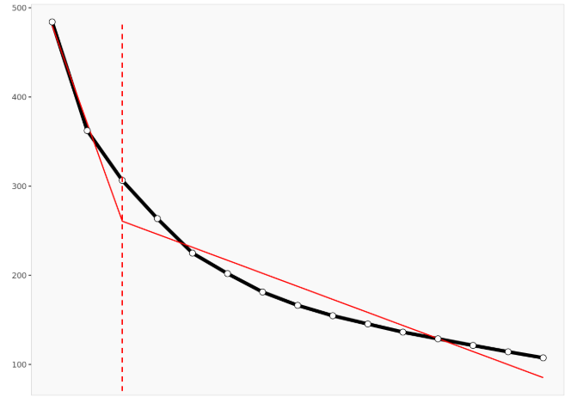

SSE drops significantly, creating an "elbow" shape in the graph, indicating that moving from 1 cluster to 3 clusters significantly improves clustering quality. Adding more clusters beyond three does not improve clustering, making three clusters the optimal choice. It does not lead to a dramatic decrease in the within-cluster heterogeneity. From this chart, choosing fewer than three clusters may result in missing important customer distinctions, and choosing more than three clusters may result in less distinct clusters with added noise.

*Figure 2: Segment size and description*

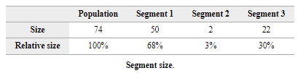

Looking at the segmentation size, it’s evident that Segment 1 is the largest segment, representing 68% of the population, whereas Segment 2 represents 3% of the population, making it the smallest segment. Segment 3 represents the remaining 30% of the population.

*Figure 3: Segment description*

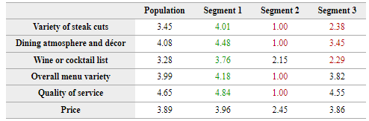

This figure provides us with overall information about how important each aspect is to customers in different segments, along with the mean rating for each aspect, which helps us tailor offerings based on customers' preferences.

*Figure 4: Descriptor data per segment*

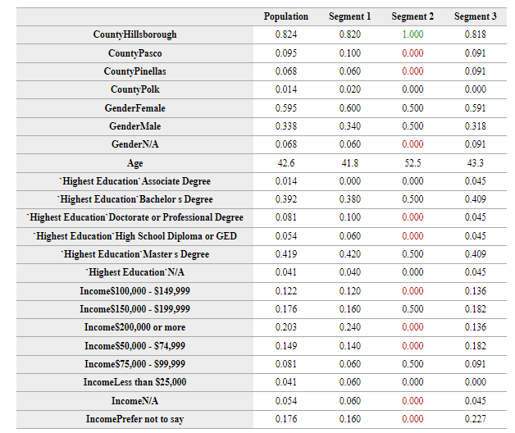

Using descriptor variables like county age, gender, highest form of education, and income will help us understand if there are any patterns among customers who prefer the same attributes in a fine-dining steakhouse.

Below is our Segmentation based on our analysis:

**Segment 1: Elite Class**

Segment 1 consists of many customers who enjoy a luxurious dining experience. They comprise 68% of the total customer base and live in Hillsborough County. The segment is predominantly 60% female and 34% male, stating that larger groups of female customers have preferences like those of male customers. With a high value of 4.48, these diners care deeply about the overall atmosphere and ambiance of the restaurant. With a high value of 4.84, they value high-quality service, making it the most crucial aspect for the customers in this segment. They also appreciate a wide variety of steak cuts and a diverse menu. While they are moderately price-conscious, it is not a significant concern compared to the dining experience's quality, and they expect value for their money.

They also care much about the extensive wine or cocktail list and the variety of steak cuts, as they are also valued highly by most of the respondents in this segment. Most of this segment comprises well-educated, higher-income individuals, many of whom hold master's or bachelor's degrees, and a few hold doctorate degrees. They are likely in their early 40s and are established in their careers. With their higher income, many customers earning $200,000 or more stated that they could afford to spend on premium dining experiences if they wanted to. Thus, they tend to expect a refined atmosphere and excellent customer service and are willing to pay for it. To appeal to this group, the restaurant should focus on delivering exceptional service, maintaining a refined atmosphere, and offering seasonal or exclusive menu options.

*Figure 5: Segment 1 Profile*

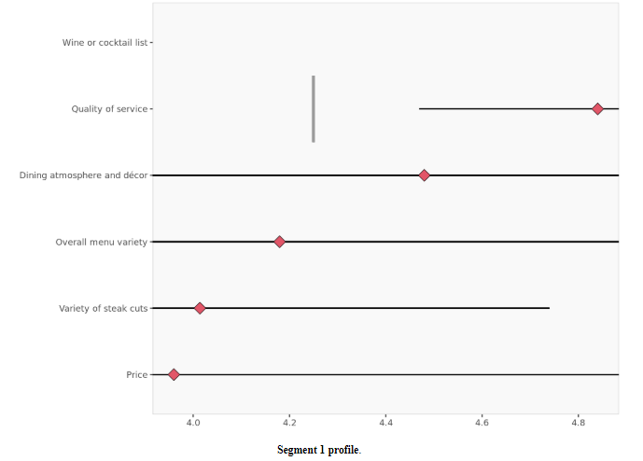

**Segment 2: Indulgent spenders**

Segment 2 is much smaller, representing only 3% of the customer base. This group places little to no emphasis on price, showing the least concern about costs among all segments. This segment has an equal proportion of males and females, saying that the customers in this segment have similar preferences regardless of gender. This group places minimal value on most dining attributes, except for a slight interest in wine or cocktail selection. Their score of 2.45 for price indicates that cost is not a consideration for them; they are willing to spend freely without worrying about value or affordability, as they are the least price-sensitive group among all segments.

Demographically, everyone in this segment lives in Hillsborough County. They are typically older, with an average age of 52.5 years. They are also relatively well-educated, with many holding bachelor's or master's degrees. Though these customers come from middle-income backgrounds, their willingness to spend makes them essential for the restaurant. Because people in this segment only look at Fleming's for fine drinking experiences, it would be better if Flemings could focus on offering a more comprehensive range of premium wines or cocktails to keep these customers interested and satisfied.

*Figure 6: Segment 2 Profile*

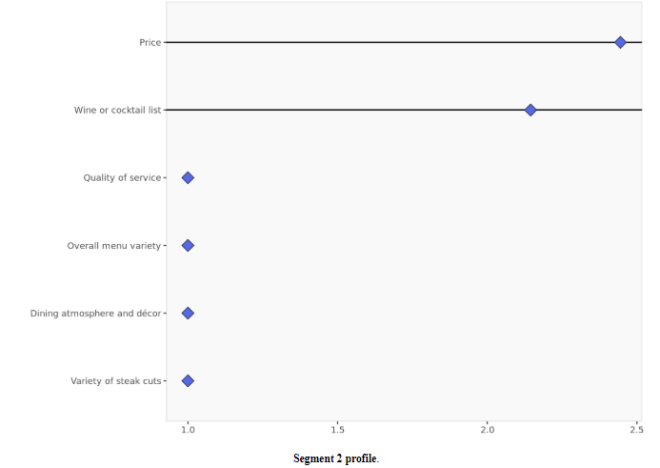

**Segment 3: Classic Steak experience lovers**

Segment 3 represents customers who love the classic steakhouse experience. They make up 30% of the total customer base and are looking for a reliable, familiar experience when they dine out. This segment consists of 59% female and 31% male, stating that larger groups of female customers have preferences like those of male customers. These diners deeply value the traditional steakhouse experience, prioritizing quality and consistency in their meals. They care most about the quality of service, followed by a well-rounded menu and a comfortable atmosphere. While steak variety and wine selection are appreciated, these elements play a secondary role compared to the core attributes of a dependable and enjoyable dining experience.

For this group, quality of service is paramount, with a high score of 4.55, making it the most essential attribute. Overall, menu variety is also a significant factor, with a score of 3.82, reflecting their desire for a menu that provides enough diversity. For the price, the score of 3.86 indicates that they are the least concerned about the cost compared to the other attributes. They are willing to pay for a high-quality experience and do not prioritize cost savings when dining out.

Additionally, this group is primarily middle-to-upper-middle-income individuals who are typically well-educated. They are usually in their 40s or 50s, and their income is moderate, with many earning between $50,000 and $100,000 a year. They value service and expect a reliable experience but are less concerned about extra perks like high-end wine selections. To cater to them, the restaurant should focus on delivering consistent quality, maintaining a comfortable ambiance, and ensuring that menu options remain familiar and dependable. Pricing strategies should balance affordability and value, ensuring this group feels they are getting the most for their money.

*Figure 7: Segment 3 Profile*

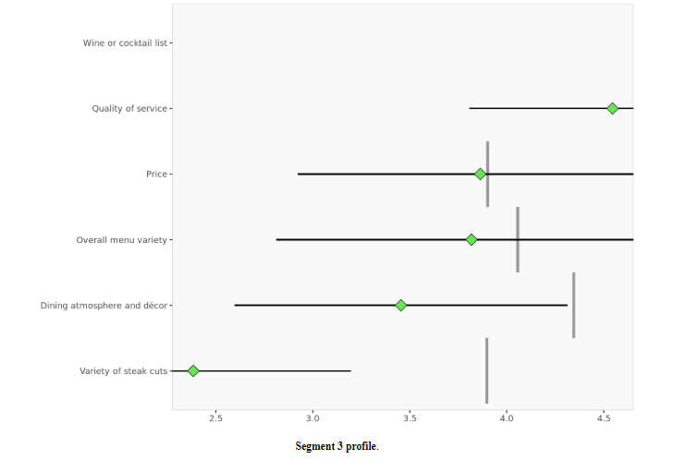

The segmentation analysis reveals three distinct customer groups with unique preferences and behaviors. Segment 1 prioritizes quality service, ambiance, and menu variety, making them moderately price-conscious but willing to pay for a refined dining experience. Segment 2 is the least about price and shows minimal interest in most dining attributes, with a slight preference for wine or cocktails, showcasing their interest in fine alcoholic beverages. Segment 3 values consistency, quality service, and a comfortable atmosphere, placing moderate importance on price and steak variety while appreciating a reliable and traditional steakhouse experience.

**Sentiment Analysis**

For sentiment analysis, it will answer the question, “How do our guests currently feel about Fleming’s? Our competitors?” Through this question, Fleming’s will learn how customers feel about the brand, which will provide an understanding of how they perceive customers. As discussed in the research plan, sampling and methodology section above, with sentiment analysis, customer review sites will be used, specifically Open Table and Yelp.

Since Fleming’s Steakhouse primarily uses Open Table to assess their reviews, that was the main source utilized. Yelp was a secondary source for the analysis. The results of this sentiment analysis are below in Figure 8.

*Figure 8: Word Cloud of Most Frequent Words (Without Stemming)*

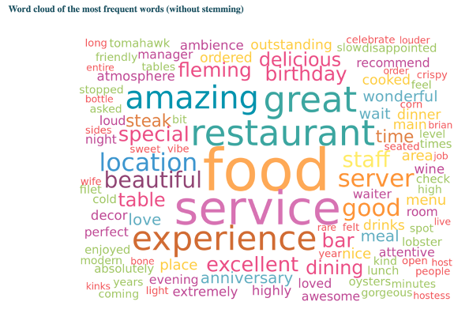

The word cloud above represents a word cloud with the most frequent words used within the review, without stemming. From this word cloud, the words that were used the most are identified, which shows what guests feel the most.

One of the most significant words used was "food," customers heavily emphasized the quality of the food they were given at the restaurant. The word "service" was used a lot, as many customers commented on the service they were provided during their dining experience. "Experience" was also frequently used in the reviews.

Specifically, this emphasizes how customers also talked a lot about the overall experience that Fleming’s Steakhouse gives while dining at their restaurant. Finally, the word "server" was also a commonly used word within the selection of reviews, indicating that customers talked about the waiters and waitresses that the restaurant provides.

*Figure 9: Percentages of Each Review (From 1 to 5 Stars)*

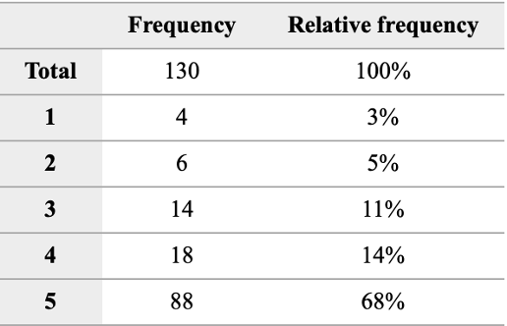

This table provides the rating frequency of how each guest reviewed the Fleming’s Steakhouse Tampa location. Out of the 130 reviews observed for the analysis, 68% were five stars, 14% were four stars, 11% were three stars, 5% were two stars, and 3% were one-star reviews.

Since the opening of Fleming's Steakhouse, 82% of responses gave 5-to-4-star reviews, showing that the restaurant is perceived relatively positively by guests who dined at the restaurant. People enjoy this new location, and the experience Fleming’s Steakhouse provides and will likely return based on their positive reviews. In turn, though, the remaining 18% of responses were 3-to-1-star reviews.

Specifically, these guests either had mediocre or bad experiences at Fleming’s Steakhouse. These people may give the restaurant a second chance or prefer a competitor over them when choosing a fine-dining steak restaurant.

*Figure 10: Valence Repartition (Positive and Negative Reviews)*

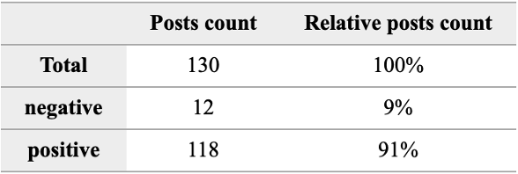

The table above represents the valence repartition of the review within this analysis. This table represents the positive and negative reviews. Shown in the table, 91% of the reviews were positive, while 9% of the reviews were negative. The 5, 4, and some of the 3-star reviews are associated as positive, while most negative associations come from 2-to-1-star reviews.

Most of the reviews indicate that guests feel positive about their overall experience at Fleming’s Steakhouse. Additionally, the negative reviews show that there was something within their experience at Fleming’s Steakhouse that they did not like, giving them that negative feeling.

*Figure 11: Word Cloud Associated with Reviews Deemed Positive or Negative*

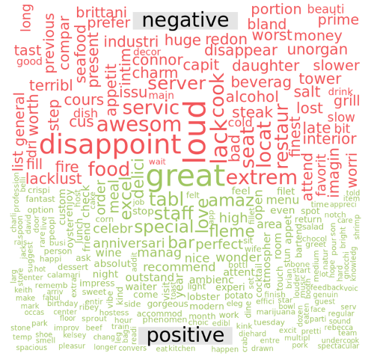

This valence word cloud represents the words associated with the reviews deemed positive or negative. First, for the positive section, there are some words that can be associated with positive guest feelings. These words are:

1. Great: With this word, guests had a great experience going to Fleming’s Steakhouse. These guests liked the service and food they received while dining at their restaurant.
   1. Review from 10/23/2024: “Clarence was excellent as always. We have eaten here a few times and he’s been our server. The last time we ate here was at the old location and he remembered us. He also accommodated a request for the lobster mac & cheese, which is a favorite. Thank you for a **great** experience.”
2. Staff: Overall, guests had a positive feeling about the service they received. Specifically, in the reviews, they gave the names of waiters and waitresses they had and told people to recommend them. Importantly, the staff was nice and very helpful when they visited Fleming’s Steakhouse.
   1. Review from 10/19/2024: “1st time here food was good. Keith our server was amazing!! All the **staff** was great! Great bday experience!”
3. Celebration: Guests consider Fleming’s Steakhouse a positive experience for celebrations. Many customers emphasized that they were provided with fantastic service for their celebrations, like birthday parties and anniversaries.
   1. Review from 10/13/2024 highlighting birthday celebration: “It was my wife **birthday** and really everything was perfect. The service provided by George was amazing and every single dish we ordered absolutely perfect!”

For negative reviews, the most notable words were:

1. Loud: Guests who gave negative reviews complained that the overall environment was too loud, which made them dissatisfied with dining there, and they will likely not go there again.
   1. Review from 10/03/2024 talking about noise levels: “Lovely remodel. Two main pieces of feedback: 1) dining room **noise level pretty high**. 2) dress code: disappointed to see patrons wearing graphic t-shirts, baseball caps and gym shoes.”
2. Disappoint: Overall, guests were disappointed with their overall experience at Fleming’s Steakhouse. When going there, they expected more from the overall experience, which they did not get when dining at the restaurant.
   1. Review from 10/25/2024: “Beautiful decor, but **disappointing** food and service. Steak was thin, not cooked as requested, Brussels dry, and it took forever to get our food. Water was not filled, generally lackluster service.”
3. Service: As service was a positive word, it was also associated with a negative feeling. Guests were given negative reviews and were not pleased with the service, saying that the food took too long to come out and that they waited longer than expected to get seated.
   1. Review from 10/18/2024: “Asked to split a soup and it came out in one bowl, two spoons. Most steakhouses would have served it in two bowls. Dessert spoon came out dirty (not clean) and had to ask for another. General disfunction was very apparent. Our waitress had a positive attitude, and I appreciated that she would check on us and apologize for whatever mishaps were happening. This feedback is not applicable to her at all but rather the overall logistics. I’ll give it another try in a few months as the food was delicious but definitely **not the Flemings service I remember or expected**.”

*Figure 12: Valence Reparation (Multiple Emotions)*

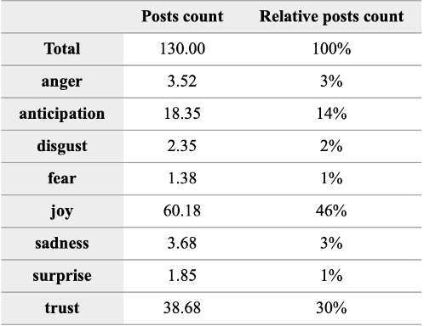

This table represents the emotional repartition of the reviews analyzed within this analysis. Based on these reviews, most of the reviews represented joy (46%), trust (30%), and anticipation (14%). From this, people who go to Fleming’s have joy when at their restraint, trust the service and the overall experience they will get, and anticipate when going to Fleming’s Steakhouse. Importantly, this shows that Fleming’s Steakhouse is credible and exciting. Additionally, sadness and anger take up 6% of the reviews, showing that people were overall disappointed and angry about the experience they had at their restaurant.

*Figure 13: Word Cloud Associated with Reviews Deemed by the Multiple Emotions*

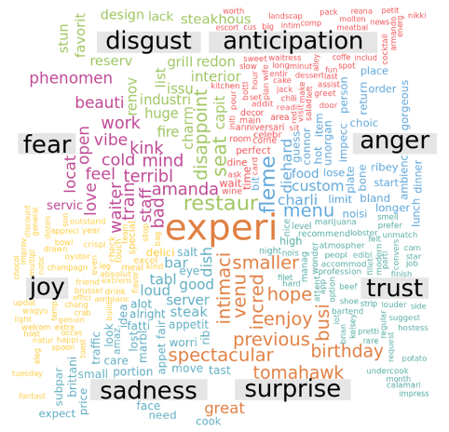

Figure 5 represents the emotion word cloud. As noted above, experience is the most significant word used and was associated most with the emotion of surprise. Overall, customers were positively surprised with the experience that the staff of Fleming’s Steakhouse gave them.

* Review from 09/13/2024: “Excellent dining **experience** at the gorgeous new flagship restaurant. Accommodated my preferences and took wonderful care of us. Thank you!”

As there are positive emotions, there are negative emotions. Specifically, disappointment was correlated with disgust the most.

* Review from 09/13/2024: “The new restaurant is a huge **disappointment**. Loud, industrial and lacking in charm. The designer should be fired and the interior redone. Once my favorite steakhouse is off our list and we will go to Capital Grill.”

People were disgusted and disappointed with the overall experience they were given. However, it is essential to understand that these reviews were more minor than guests' positive experiences at Fleming’s Steakhouse. Importantly, these are reviews they should look at to understand why.

**Perceptual Maps**

Perceptual maps help us visually understand how consumers perceive a particular product compared to its competitors. Perceptual maps are used to identify Fleming’s strengths in relation to the attributes it strongly correlates with and to evaluate how its peers perform on those same attributes. Five attributes were analyzed to assess the performance of the selected restaurants. The attributes include variety of steak cuts, dining atmosphere and decor, wine/cocktail list, overall menu variety, quality of service, and price. First, the dimensions must be looked at.

*Figure 14: Variance Explained Chart*

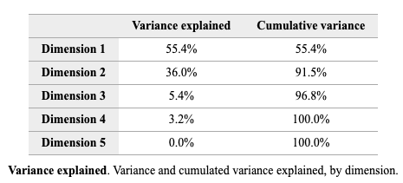

The first two dimensions collectively explain 91.5% of the variance in the data. The third dimension captures only a 5.4% variance in the data. Since the third dimension captures only a tiny amount, the first two dimensions will only be considered. Dimensions refer to the critical attributes along which products or brands are compared. These attributes form the map's axes, representing the criteria consumers use to perceive differences between the products. Each dimension is a collection of attributes that summarizes customer perceptions of products. When plotting brands on the map, their relative positions along these dimensions reveal how similar or different customers perceive them. Since the first dimension explains 55.4% of the variance in the data, it is more important than the second dimension in terms of explaining customer perceptions.

The key attributes for dimension 1 and dimension 2 are as follows.

*Figure 15: Dimension Interpretation Chart*

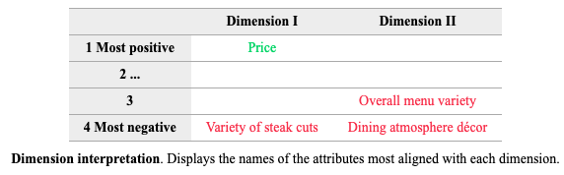

The attributes of the Price and Variety of steak cuts align with the first dimension. However, price positively aligns with the first dimension, and the variety of steak cuts negatively aligns with the first dimension. This means the attributes are inversely related to each other along the first dimension. On the other hand, overall menu variety, and dining atmosphere and decor negatively align with the second dimension. These attributes define the negative end of the dimension, meaning that the dimension is strongly associated with those attributes on its negative side. A low negative score means the restaurant may be strongly associated with those attributes. The position of the restaurants is based on the two dimensions.

*Figure 16: Graph of Objects Positioned on First and Second Dimension*

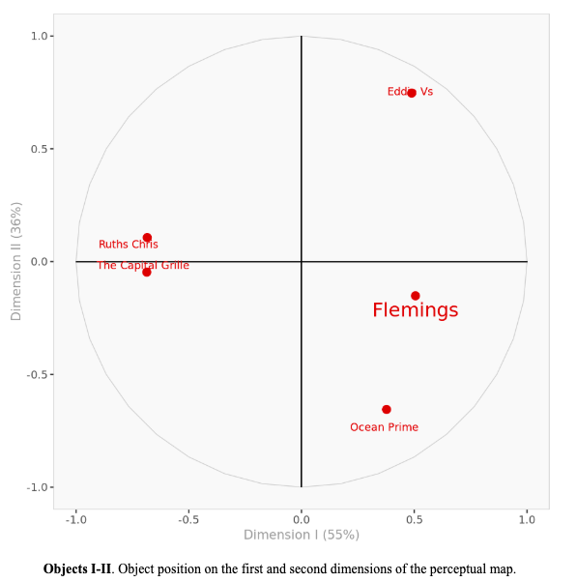

The first dimension explains 55% of the variance in the data and is horizontal. The second dimension explains 36% of the variance in the data and is vertical. Based on this map, it’s inferred that Ruth's Chris and The Capital Grille are similar as their distance is relatively small. They are far into the negative side of the first dimension, which indicates that they are perceived as having a variety of steak cuts but are not that affordable. Eddie V's is in the upper right corner of the first quadrant, indicating that it is affordable but does not offer a variety of steak cuts. It also does not have great overall menu variety and lacks an exquisite dining atmosphere and decor because its position is on the positive side of the second dimension.

Flemings and Ocean Prime are in the fourth quadrant. Flemings's position indicates that it is somewhat affordable but may lack a variety of cuts. However, it is on the negative side of the second dimension, indicating that its overall menu variety is not that bad, and it houses a fantastic dining atmosphere and decor. Ocean Prime has a lower score than Flemings in the second dimension, indicating a better overall menu and dining atmosphere than Flemings. It is less affordable but offers a greater variety of steak cuts.

To analyze their positioning accurately, the perceptual map will display how the restaurants have been positioned with respect to the attributes.

*Figure 17: Objects and Attributes on the First and Second Dimensions*

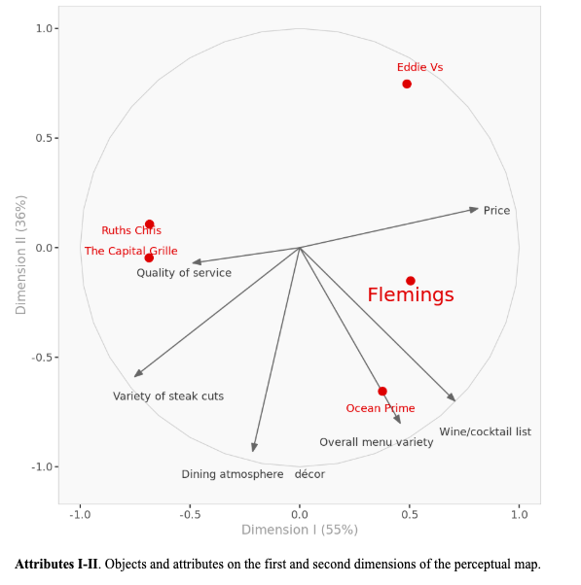

The attributes of the overall menu variety and wine/cocktail list go in the same direction; therefore, they positively correlate with each other. Since the restaurant Ocean Prime aligns with the attribute vector of overall menu variety, it reinforces that it is perceived as having incredible menu variety. Moreover, since this attribute vector is close to the attribute vector of the wine/cocktail list, it means that Ocean Prime has a great list of wines and cocktails. The dining atmosphere is fantastic as well.

The same goes for Fleming’s. However, Flemings's position is slightly above Ocean Prime, indicating that although it offers incredible menu variety and a wine and cocktails list, it is not as good as Ocean Prime's. It has much to catch up with in that respect. However, both are on the positive side of price, indicating affordability but not much variety in steak cuts, as shown by the fact that price is negatively correlated with the attribute vector of variety of steak cuts.

Ruth's Chris and Capital Grille are on the negative side of Dimension 1. They are perceived as having a variety of steak cuts and are relatively expensive. However, they offer little menu variety and wines, and they need to improve the overall dining experience. Eddie V's is in the upper right-hand corner, indicating that it is the most affordable restaurant but lacks a variety of attributes, including steak cuts, decor, menu, and wine/cocktail lists.

The lengths of the attribute vectors are long except for quality of service. This means that the two dimensions captured them well. Since that attribute is closer to the origin, it seems better captured by the third dimension. The software will be run using three dimensions.

*Figure 18: Dimension Interpretation Chart*

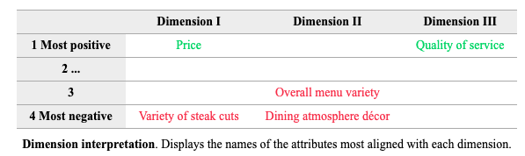

Quality of service positively aligns with the third dimension. The first- and third-dimension maps will be analyzed first to see how the restaurants perform in terms of quality of service.

*Figure 19: Objects Positioned on the First and Third Dimension*

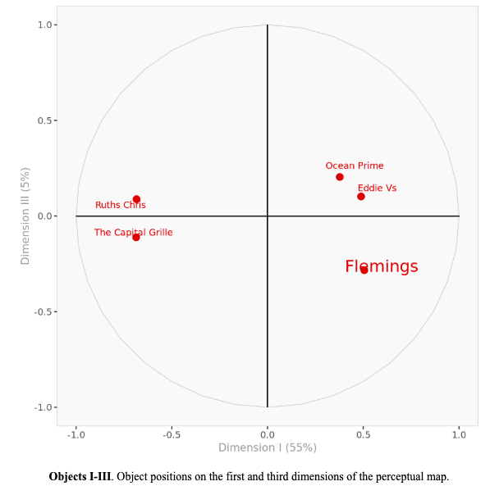

Our third dimension explains around 5% of the variance in the data and is vertical in the above diagram. Fleming’s, our focal brand, performs negatively with respect to this attribute. It lies on the negative side of the third dimension, indicating that it has poor quality of service. Ocean Prime, its closest competitor, performs well compared to Eddie V's, Ruth's Chris and Fleming’s.

*Figure 20: Objects and Attributes on the First and Third Dimension*

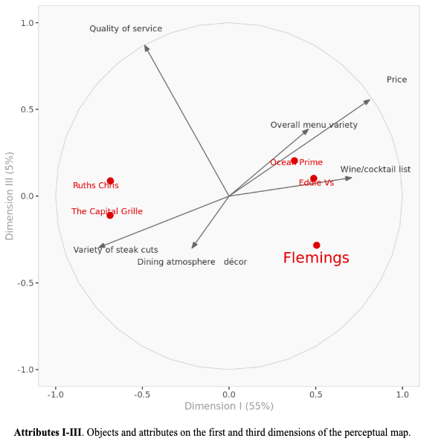

The quality-of-service attribute vector is the longest in the above perceptual map, indicating that the third dimension captures it well. Flemings is in the opposite direction of that vector, while all the other restaurants are on the positive side of it.

Looking further into the perceptual data, the average attribute score for each restaurant is calculated below:

*Figure 21: Average Attribute Score for each Restaurant*

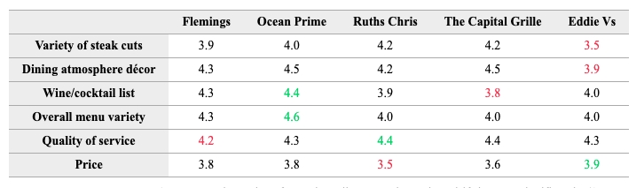

Fleming’s has an average performance with respect to all attributes except quality of service. The perception value of quality of service is significantly less than the average perception value of all restaurants. Ocean Prime has the highest perception value for menu variety and wine/cocktail list. Ruth’s Chris is the best in terms of quality of service, but it does not perform well with respect to prices. This is an indication of the fact that it focuses more on a variety of steak cuts causing its prices to be higher than average. Eddie V’s is the most affordable restaurant, but it does not offer a variety of steak cuts.

The above analysis has shown us that all our fine-dining steakhouse restaurants are unique in their own way. The consumers perceive them differently with respect to the attributes they were asked to rate. However, Fleming’s is perceived to be an average fine-dining steakhouse restaurant with poor quality of service. We can see from our perceptual map that Ocean Prime is perceived as being quite similar to Fleming’s, but it is better in terms of offering a better menu and wine/cocktail list. However, both restaurants fail to offer a variety of steak cuts, which are taken care of by Ruth's Chris and The Capital Grille. Moreover, Ruth's Chris is more expensive as well. Eddie V's is the most affordable of all restaurants, indicating that it could cater to the more middle-class consumers.

Now, segmentation analysis must be observed again through examining *Figure 3* to understand our consumers' preferences.



The first segment values the variety of steak cuts, dining atmosphere and decor, wine or cocktails list, overall menu variety, and quality of service the most. These consumers are passionate about their dining experience at a high-end steakhouse and wine restaurant. They do not care about the price that much. They even constituted the highest proportion of our sample of respondents. Compared to the first segment, the other two are not concerned about the steak cuts, wine list, or even their dining experience.

Eddie V's is a good option for the second and third segments. For the First segment, our primary target audience, Fleming's, which projects itself as a fine-dining steakhouse restaurant, is not meeting their expectations. They value a variety of things in their ideal steakhouse restaurant. Moreover, Flemings only offers poor-quality service. On the contrary, Ocean Prime offers a fantastic menu and wine/cocktail list. It even has better service. Even though its price range is quite like Flemings, it offers more variety in steak cuts. Ruth's Chris and The Capital Grille offer an exquisite variety of steak cuts and are on the pricier side. However, given the customer preferences, the price attribute is of less concern. Therefore, that is something that can be ignored. Both restaurants have better quality of service than Fleming’s.

**Recommendation**

**Segmentation**

After performing the segmentation analysis, the question was answered successfully by identifying and explaining the patterns in customer preferences and demographic characteristics. Customers in each segment share common values and behaviors regarding dining experiences. Thus, the following strategies are recommended to effectively meet the needs of each segment while enhancing Fleming's position as a fine-dining steakhouse.

**Segment 1: Elite Class**

For the Elite Class, creating a high-end dining experience is essential. These customers value excellent service and a refined, elegant atmosphere. They should focus on providing personalized service where staff are attentive and knowledgeable. The restaurant's ambiance should feel exclusive and comfortable, with attention to small details. Introduce special menu items available only for this group and offer fine wine pairings to match their sophisticated tastes. Market Fleming's as a place for luxury and exclusivity, emphasizing the premium experience that this group expects.

**Segment 2: Indulgent Spenders**

The Indulgent Spenders care less about price and more about enjoying the best of what Fleming’s offer for drinks. The best recommendation would be to expand our wine and cocktail options, offering premium selections and signature cocktails. This group values quality beverages, so creating experiences like wine tastings or special drink events can keep them interested. Our marketing should showcase Fleming's as a place that offers top-tier drinks and experiences.

**Segment 3: Classic Steakhouse experience Lovers**

The classic steakhouse experience lovers appreciate a familiar and quality service over all the other factors. The best recommendation would be to deliver consistent, high-quality steaks and excellent service every time. Keeping the menu simple with various dishes and featuring classic steakhouse options would always satisfy people in this segment. They are not looking for novelty but for quality and value. Marketing Fleming's as a trusted spot for great steaks and dependable service, along with making sure they feel confident in the consistent quality they will receive each time they visit Fleming's, is essential.

Overall, from this segmentation analysis, Fleming's should focus on luxury and exclusivity for the elite class, offering personalized service and a great atmosphere. For Indulgent Spenders, Fleming’s should expand the wine and cocktail options with premium drinks and events. For Classic Steakhouse experience Lovers, they need to be provided with quality, reliable services to ensure they have sufficient classic steakhouse options. These strategies will meet customer needs and strengthen Fleming's reputation.

**Sentiment Analysis**

Through sentiment analysis and based on the current reviews of Fleming’s Steakhouse's flagship restaurant in Tampa, there are three main recommendations:

1. **Enhance Positive Experiences:** Highlighting “excellent” service and quality and leverage celebrations/other special occasions.
2. **Address Negative Feedback:** Managing noise service, continuously improving service speed and communication, and providing recovery options.
3. **Leverage Emotional Insights:** Including the emotions described in the reviews based on the sentiment analysis for messaging and previews.
4. **Continuous Improvement Through Feedback:** Continually analyze reviews and encourage guests to leave reviews.

For the first recommendation, as discussed, they should highlight the excellent service and quality. Fleming’s Steakhouse should also leverage celebrations and other special occasions within their restaurant. With these two things in mind, Fleming’s should gather customer testimonials that emphasize an excellent experience, which can be displayed on their website, social media, and promotional emails. They should seek individuals who can give specific details about their experiences and highlight those.

* Example: Fleming’s should find people who highlight the quality of service and specifically explain what they liked about that service overall.

Additionally, this can help make Fleming’s Steakhouse a premier destination for celebrations like birthdays and anniversaries compared to competitors. This can increase customer loyalty, improve online reputation, and elevate their current brand image.

Next, to address negative feedback, they should consider managing the noise levels, continually making sure the speed of their service and communication is consistent and develop recovery options. They can reduce noise through things like sound-absorbing panels, monitoring the speed of service and communication every day, and offering dissatisfied customers discounts or complimentary items on their next visit. Considering these things can increase overall customer satisfaction and reduce negative reviews' frequency if addressed.

Third, they should leverage the emotional insights given from the sentiment analysis. Specifically, they should include the emotions of joy and trust in their messaging and build anticipation with preview content of upcoming menu items. For example, to establish joy in their marketing campaigns, they could include a phrase like "Trust us to make your next meal unforgettable" to establish that. Additionally, for anticipation, they can also provide behind-the-scenes videos of chefs preparing food and a sneak peek of seasonal offerings. Doing this can help create a deeper connection with guests and enhance its reputation as a trusted fine-dining steakhouse.

Finally, they should continuously improve through feedback. By doing this, Fleming’s Steakhouse can monitor trends and address any future concerns. Additionally, they should encourage guests to provide reviews, like a QR code, to give their overall feeling about the Fleming’s experience. It is crucial that Fleming’s stays on top of this to always understand the never-ending changes in customer preferences.

**Perceptual Maps**

Through the use of perceptual maps, it was discerned that Flemings is not really being perceived as a restaurant that is unique in a way that sets it apart from its competitors. Hence, Fleming’s need to first analyze its shortcomings to answer the third problem: How can Flemings position itself better in the fine-dining steakhouse industry?

The first shortcoming of Flemings, which was quite obvious, was its poor quality of service. To address this problem, it should train its staff better in hospitality and fine-dining service etiquette. It could implement a feedback loop by actively collecting customer feedback on service quality and addressing complaints quickly. Flemings could introduce service incentives for staff, such as recognition programs for exceptional customer experiences.

To be on par with its closest competitor, Ocean Prime, it should try expanding the menu to include unique and diverse items that differentiate Fleming's from Ocean Prime. It could partner with renowned sommeliers to enhance the wine list or introduce seasonal wine and cocktail pairings. They should also try promoting menu innovation through seasonal specials, chef-curated dishes, or themed events (e.g., wine-tasting dinners).

Fleming's perception of offering a variety of steak cuts is somewhat okay, a strength of competitors like Ruth's and The Capital Grille. Therefore, they should expand the steak menu to include rare or specialty cuts (e.g., more versions of Wagyu, Tomahawk, or Dry-aged beef). They could highlight the sourcing and quality of steak offerings in marketing campaigns to reinforce the premium steakhouse identity. They could even offer customization options for steak cuts and preparations to appeal to steak enthusiasts.

Flemings positioned positively on price, indicating affordability, a strength compared to pricier competitors. However, it is something that they should not worry about that much because none of our segments had price as a significant concern. Flemings also offers an exceptional dining experience with great decor. Therefore, in their marketing campaigns, they should emphasize that. Flemings could even enhance this experience by updating their interiors with modern, luxurious elements to elevate the ambiance further and introduce subtle improvements, such as live music on weekends, updated lighting, or seasonal décor themes, to make the atmosphere more memorable.

**Conclusion**

Through marketing analytics tools such as sentiment analysis, perceptual mapping, and segmentation, Fleming’s Steakhouse and Wine Bar gained critical insights about customer perceptions, strengths, and areas for improvement for their Tampa location. Fleming’s is perceived as an average fine-dining steakhouse, performing well in a dining atmosphere, decor, and affordability; however, it falls short in the quality of service, steak variety, and menu innovation compared to its competitors: Ruth’s Chris, The Capital Grille Eddie V’s, and Ocean Prime.

Positive reviews frequently highlight excellent service, personalized experiences, and celebration accommodations. Conversely, negative feedback focuses on loud noise levels, slow service, and logistical issues. Key emotional insights demonstrate that most customers associate Fleming’s with joy, trust, and anticipation, though some express disappointment and frustration.

The segmentation analysis identified three customer groups: the Elite Class, Indulgent Spenders, and Classic Steak Lovers. The Elite Class values luxury, exceptional service, and exclusivity. Indulgent Spenders prioritize premium wine and cocktails. Classic Steakhouse experience Lovers prefer consistency, quality, and traditional steakhouse offerings. Fleming’s current positioning struggles to fully satisfy these segments, especially the Elite Class, as competitors like Ocean Prime and Ruth’s Chris outperform it in menu variety, service quality, and steak options.

Perceptual mapping highlights Fleming’s strengths are affordability and dining ambiance, while its weaknesses are steak variety and service quality. Ocean Prime was identified as the closest competitor, excelling in both menu innovation and wine offerings. Ruth’s Chris and The Capital Grille, owned by the Darden Restaurants group, lead in steak variety.

Based on the data collected, it is recommended that Fleming’s needs to improve service through consistent staff training, feedback forms, and incentive programs, enhancing menu variety with rare steak cuts and innovative seasonal offerings, and promoting a luxurious atmosphere through targeted marketing campaigns (email, social media, DOOH, paid media, display ads). Encouraging customers to leave reviews, leveraging emotional insights in marketing messaging, and addressing service-related complaints can enhance the brand’s perception. Ultimately, these strategies will strengthen Fleming’s positioning as the premier fine-dining steakhouse, appealing to a diverse customer base that will dine repeatedly and remain loyal to Fleming’s Prime Steakhouse and Wine Bar throughout the years.

Appendix

Appendix 1: Survey Questions

1. Which county do you currently reside in?
   1. Hillsborough
   2. Pasco
   3. Pinellas
   4. Polk
   5. Other
2. Rate how importance each of these attributes are to you when dining at a fine-dining steakhouse. (1 = Not important, 5 = Very important)
   1. Variety of steak cuts
   2. Dining atmosphere & décor
   3. Wine/cocktail list
   4. Overall menu variety
   5. Quality of service
   6. Price
3. Which fine-dining steakhouses have you dined at IN TAMPA within the past year, if any?
   1. Eddie V’s Prime Seafood
   2. Fleming’s Prime Steakhouse & Wine Bar
   3. Ocean Prime
   4. Ruth’s Chris
   5. The Capital Grille

Depending on what the respondent selects in Question 3, they will receive the following questions for each restaurant they select.

1. What was the purpose of your visit?
2. Please rate (insert restaurant here) in Tampa on the following attributes. (1 = Poor, 5 = Excellent)
   1. Variety of steak cuts
   2. Dining atmosphere & décor
   3. Wine/cocktail list
   4. Overall menu variety
   5. Quality of service
   6. Price

Demographics

1. What do you identify as?
   1. Male
   2. Female
   3. Non-binary / third gender
   4. Prefer not to say
2. What is your age in years? ____________
3. What is your highest degree of education?
   1. Some High School, No Diploma
   2. High School Diploma or GED
   3. Associate Degree
   4. Bachelor's Degree
   5. Master's Degree
   6. Doctorate or Professional Degree
4. What is your annual household income?
   1. Less than $25,000
   2. $25,000 - $49,999
   3. $50,000 - $74,999
   4. $75,000 - $99,999
   5. $100,000 - $149,999
   6. $150,000 - $199,999
   7. $200,000 or more
   8. Prefer not to say

Works Cited

IBISWorld. (2024). *Title of the report*. Retrieved from <https://my-ibisworld-com.esearch.ut.edu/us/en/industry-specialized/OD4309/performance>